Part 1: Staff-side

Notifying patron:

1) Begin from your library’s home page.

Hollis: <https://hslill.github.io/hsl-lockers/index-hollis.html>

Lapidus: <https://hslill.github.io/hsl-lockers/index-lapidus.html>

Robbins: <https://hslill.github.io/hsl-lockers/index-robbins.html>

2) Use the information on the book wrap to fill in the corresponding fields on the webform.

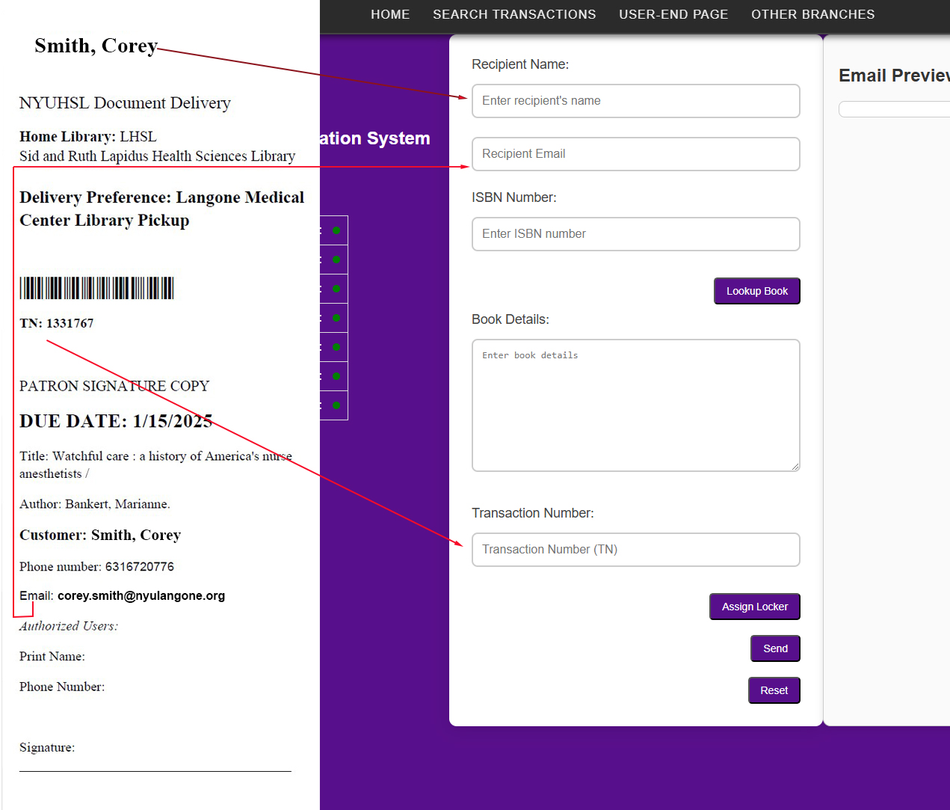

3) Enter Book Details

You can either lookup a book by ISBN or manually entering the book’s information directly into the Book Details text field. Optionally, include the transaction number (e.g., tn: 1331767) in the bottom line. This will make it easier to keep track of contents inside of lockers.



4) Click Assign Locker Button

A popup will alert that a locker has been assigned.

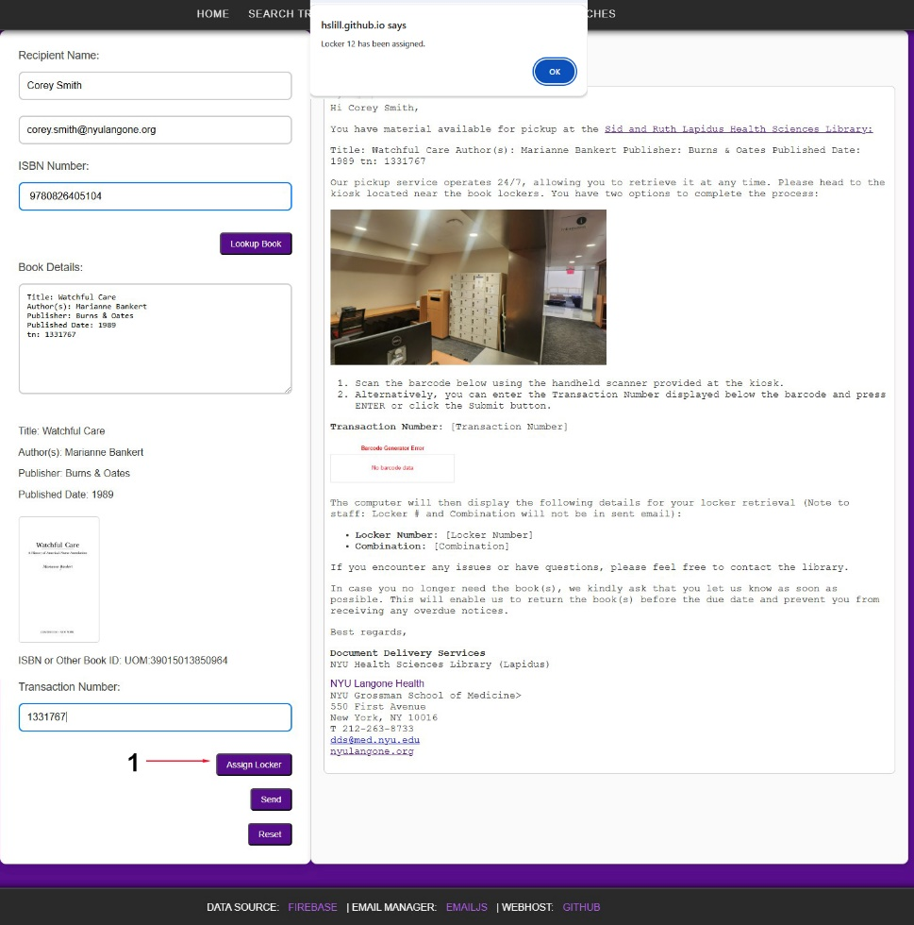

After clicking OK to the popup, the preview email will be updated with a transaction number barcode, Locker Number and Combination for use in storing the book.

5) Send the Notification

After assigning the locker, click the Send button. An alert will notify staff that the email was sent successfully.

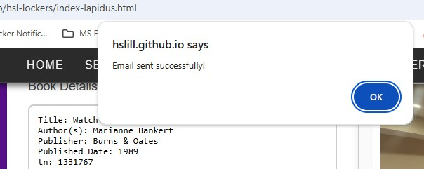

6) Reset the page to update the Locker Status dashboard. To view the contents of the locker, hover the cursor over the red dot to the right of the locker number.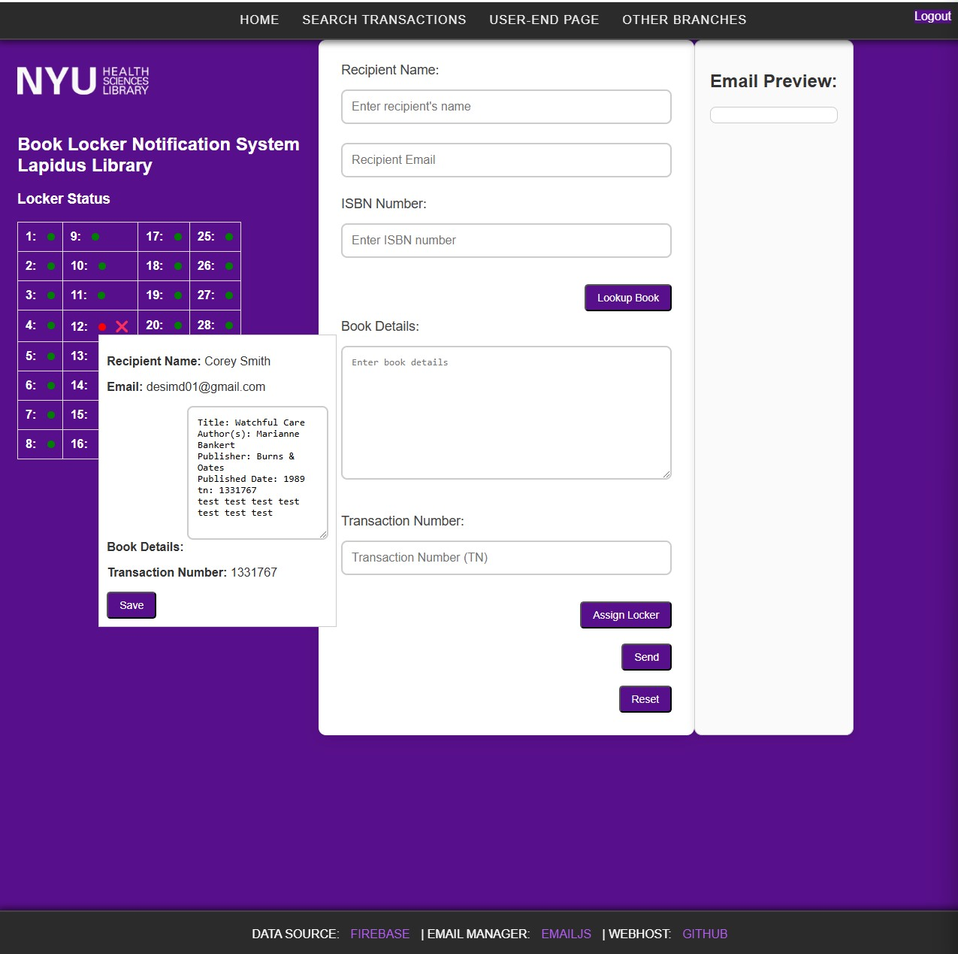

1-2-3 Image Summary

After filling out the notification fields 1) Click Assign Locker; 2) Click Send; 3) Reset after recording the locker number and combination.

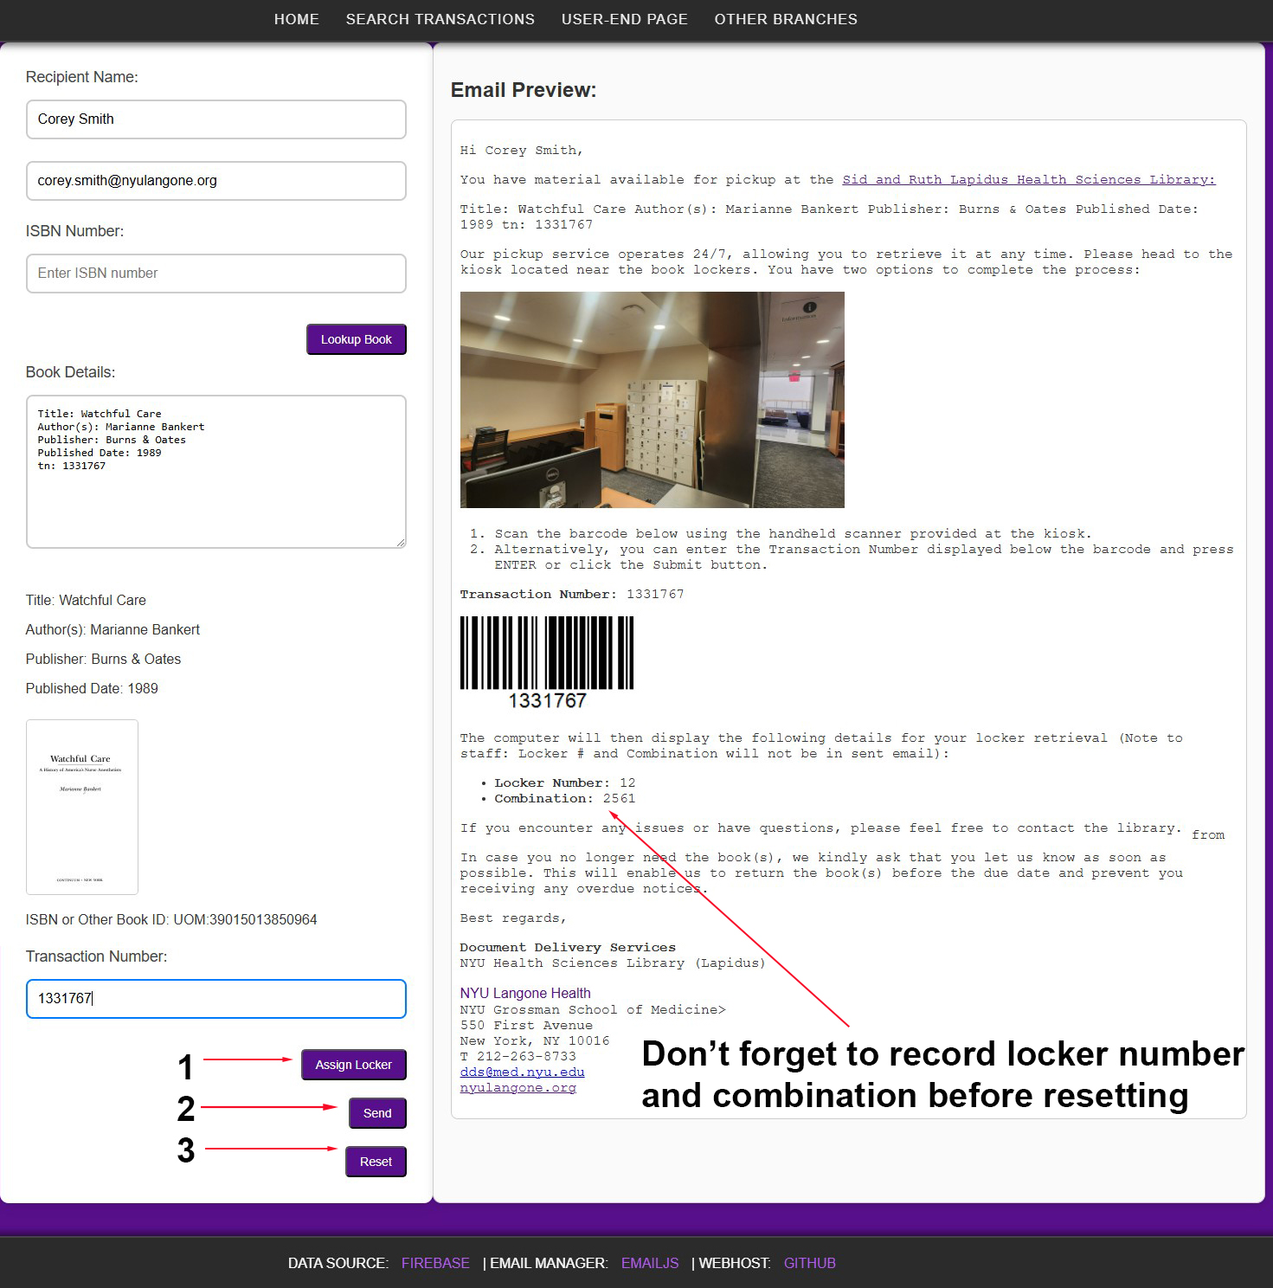

7) How to Edit Locker Information in the Popup Window:

1) Hover over the Locker Number to open the popup with the locker’s details.

2) Once the popup appears, hold down the Alt key until the window stays open (this is called "sticking" to the screen).

3) After the window stays open, you can make changes and **Save** them without holding the Alt key anymore.

If the popup doesn’t stay open, try clicking the locker number first to focus on the page, then press the Alt key.

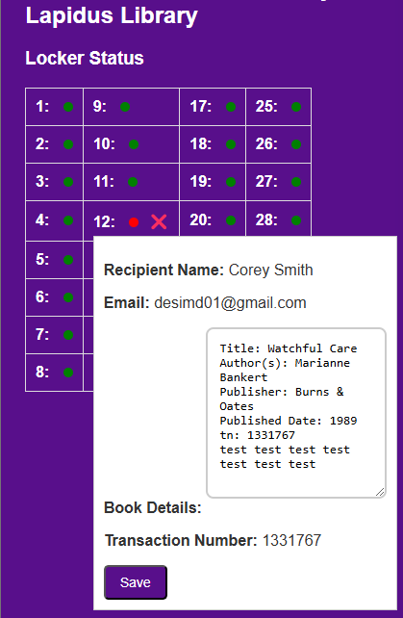

Part 2: User-side

1) Email Notice

When the notification is sent by staff, the patron receives an email that looks like this.

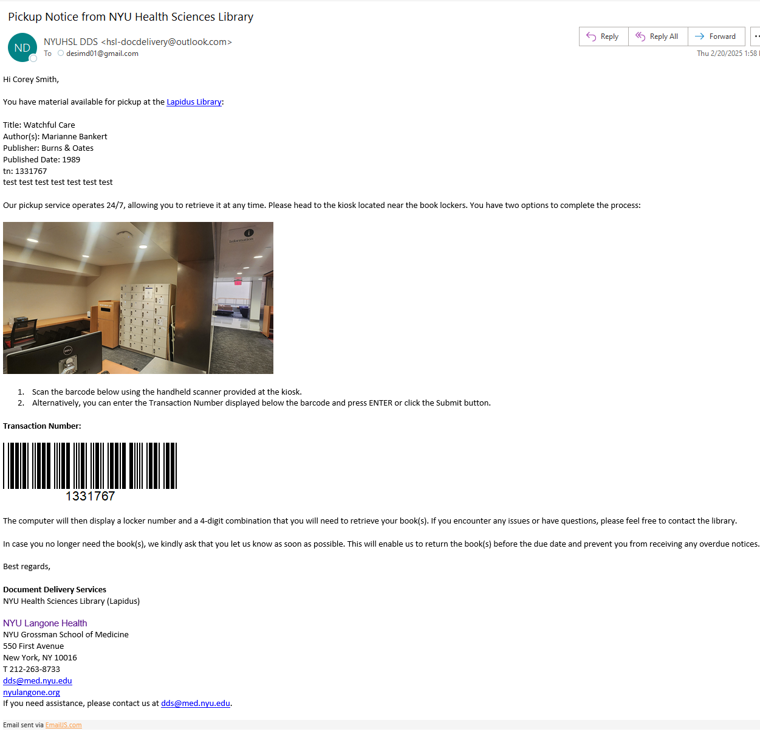

The message contains all the information the patron needs to retrieve the contents from a locker, including pick-up address and a barcode.

Document Delivery Services receives a copy of the email sent to the patron. This is done so they know a book was received by staff and the patron was notified.

2) Kiosk Interface

Links for Libraries to set up on their respective public kiosks:

Hollis: <https://hslill.github.io/hsl-lockers/user-index-hollis.html>

Lapidus: <https://hslill.github.io/hsl-lockers/user-index-lapidus.html>

Robbins: <https://hslill.github.io/hsl-lockers/user-index-robbins.html>

The patron will go to the kiosk near the lockers and either use the barcode in the email message or keyboard to enter the transaction number.

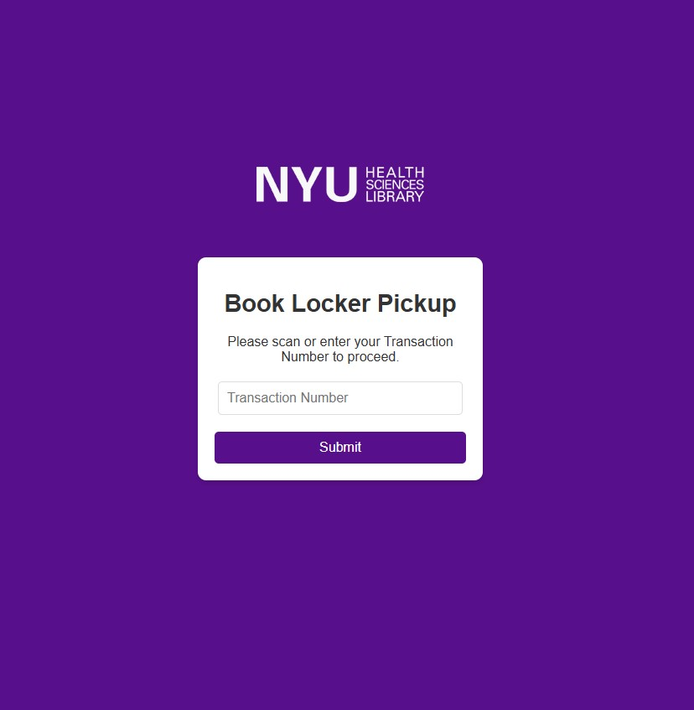

3) Locker Information

When the patron enters the transaction number and clicks Submit, the display will provide a locker number and combination for the patron to use to retrieve their contents, along with a timestamp of pick-up that is saved to the database.

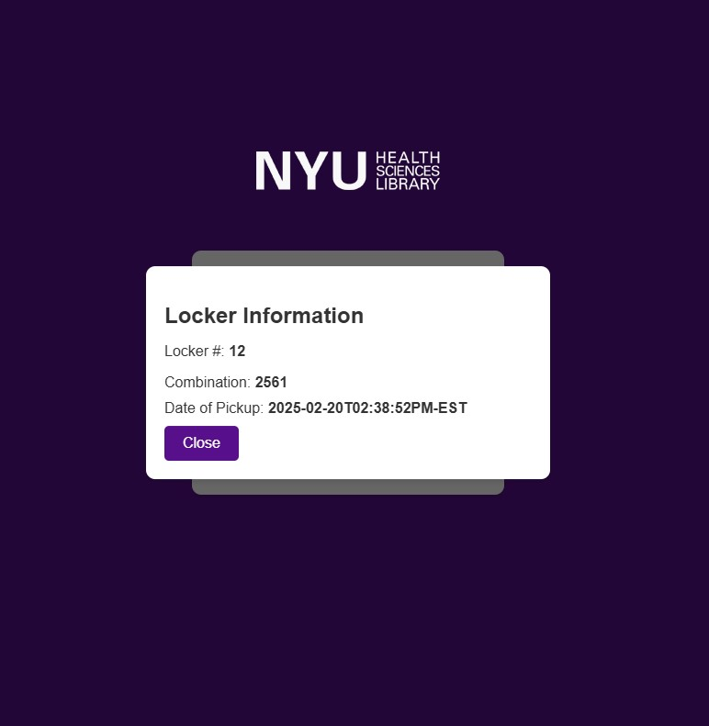

If the active window isn’t closed by the patron, the page will reset after 30 seconds.

Document Delivery Services receives a confirmation email notifying that a book was picked up.

Part 3: Adding Books to Records and Notifying Patrons

The Book Locker Notification System has a feature that enables staff to add books and notify patrons of the update.

1) From the homepage, Search Transactions.

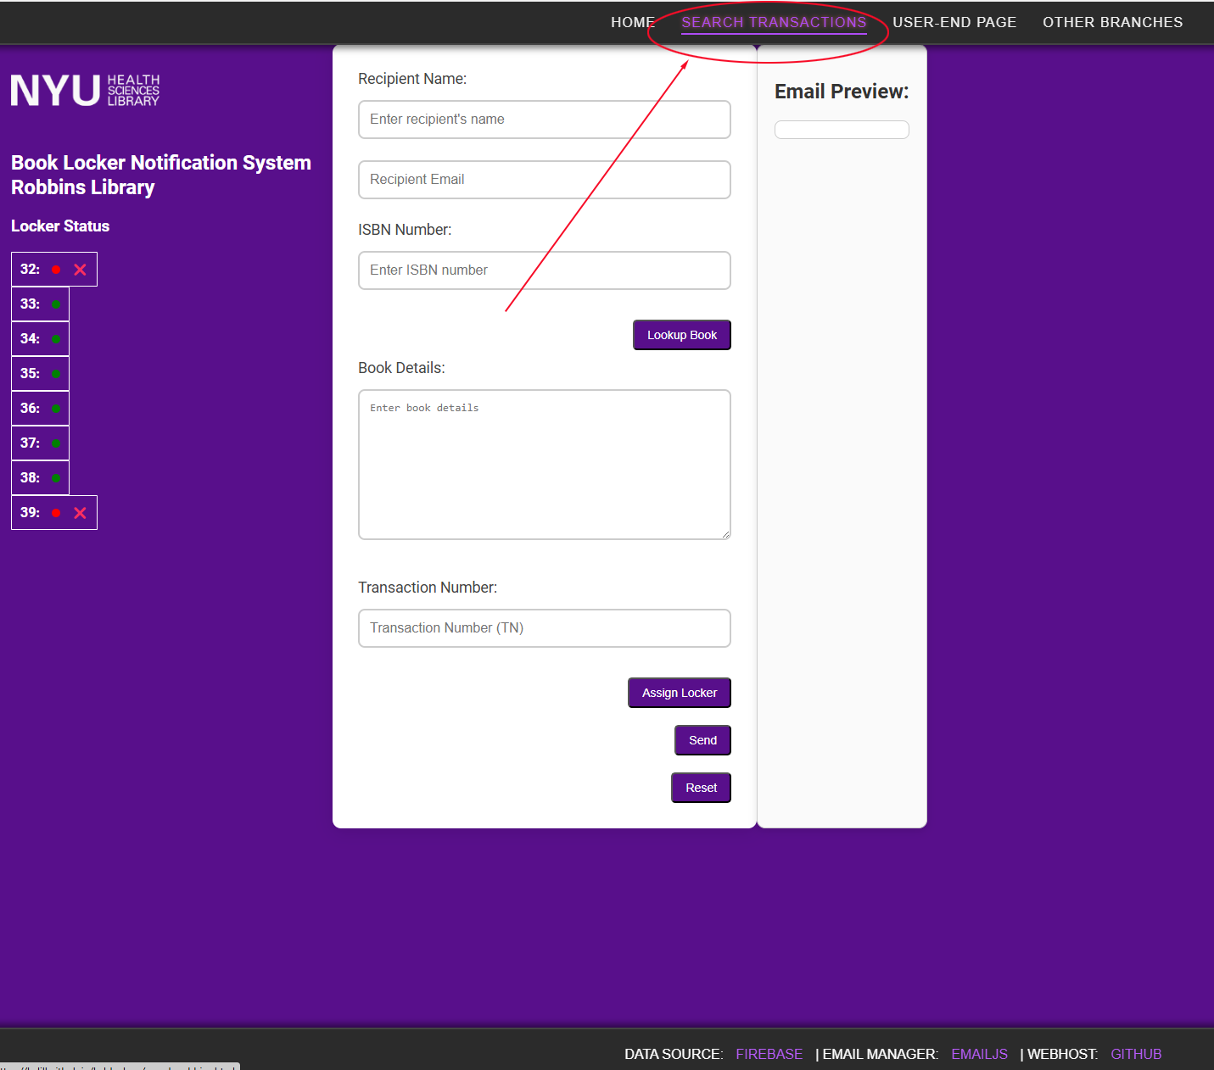

2) Search by transaction number, recipient name or email. When the record displays, find the Edit button.

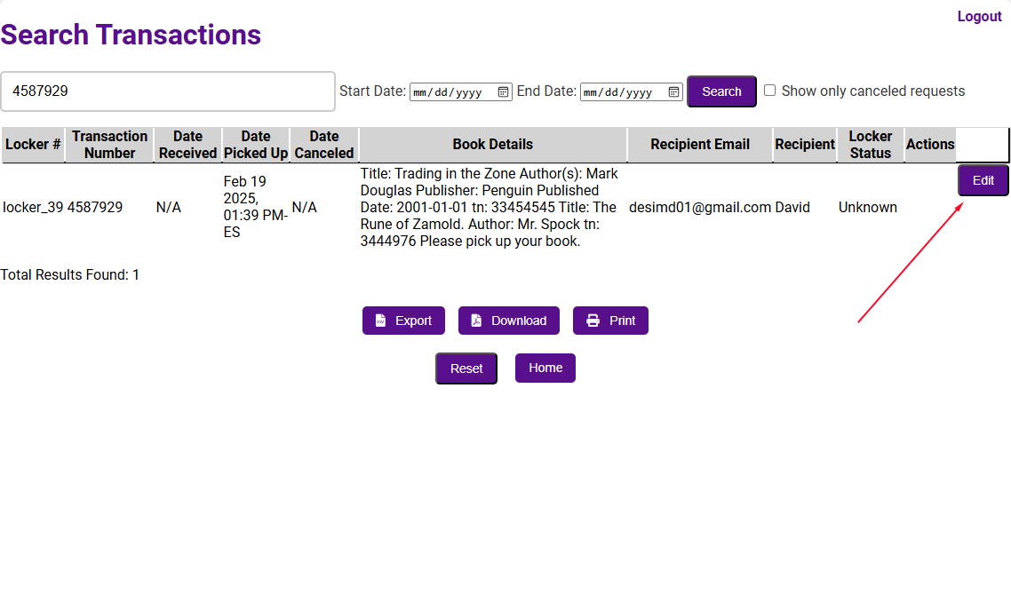

3) Use the Book Details field to enter the book information. To make reading the message easier for the patron, it is recommended to separate each line by category. For Document Delivery Services and library staff convenience, it is also recommended to include the transaction number (tn) . E.g.

Title: Trading in the Zone

Author: Mark Douglas

tn: 1434443

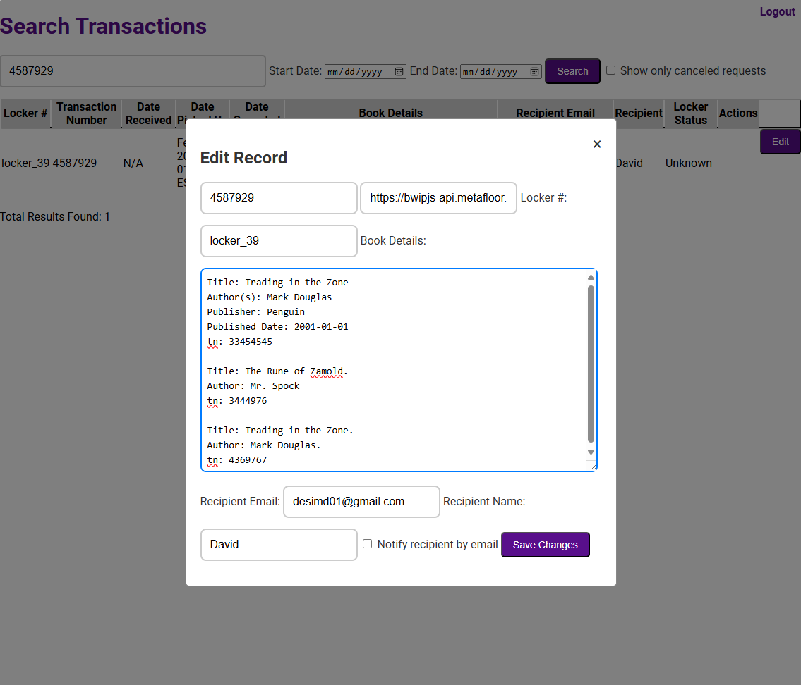

4) Check the box “Notify recipient by email” to send your updates to the recipient.

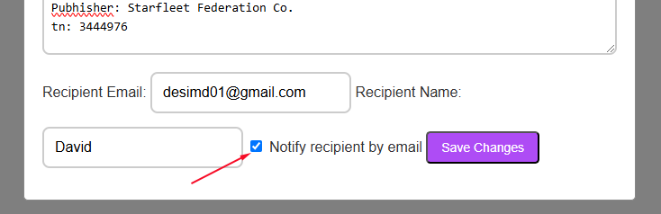

5) Click the Save Changes button to:

1) update record.

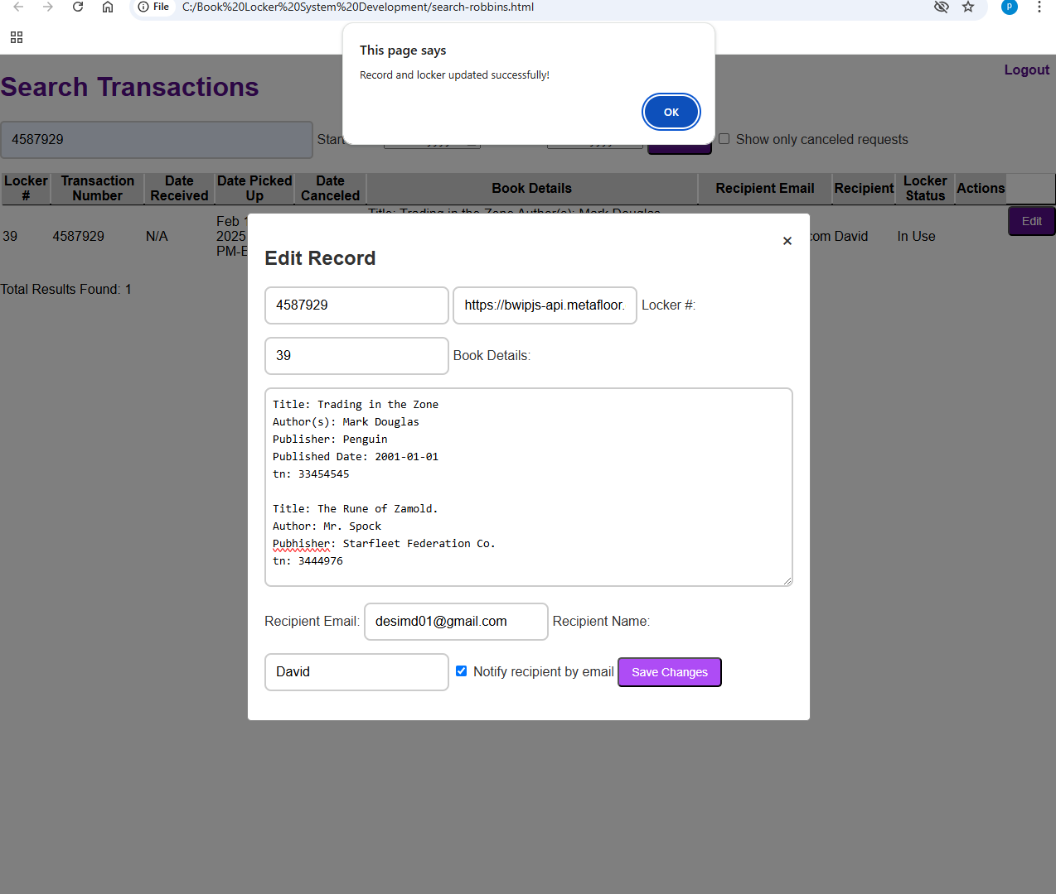

2) Email recipient.

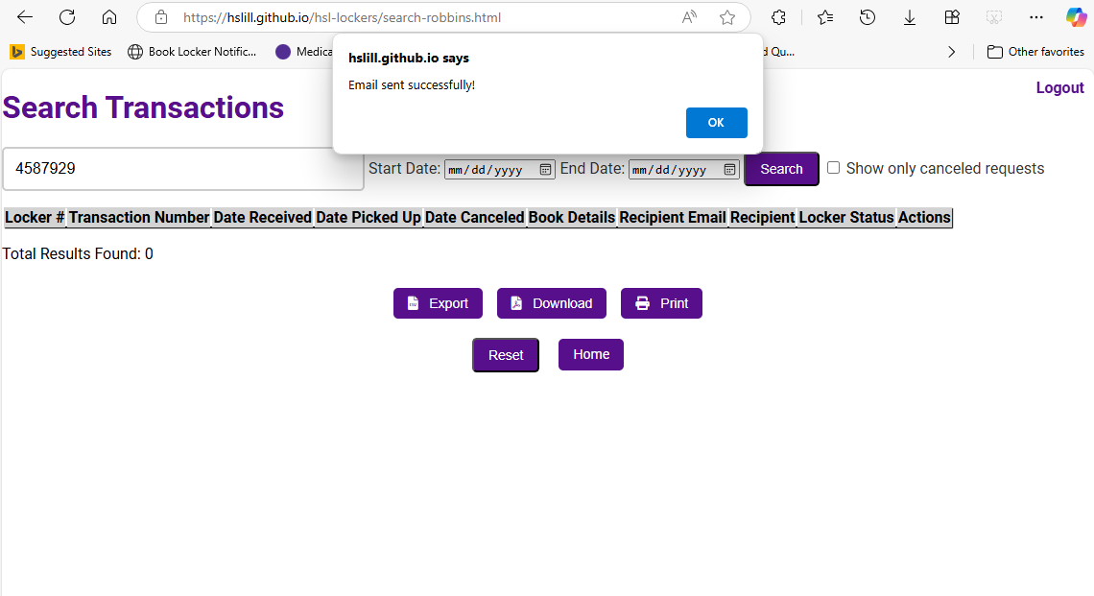

6) The recipient receives an email similar to the original, but that includes the update.

